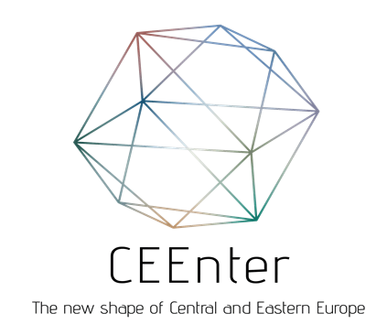

Applications are invited for the fourth edition of Tourism Award Marco Polo, from 14th March
The China-CEEC’s Tourism Coordination Centre invites applications for the 2022 edition of Tourism Award Marco Polo.
Travel agencies, tour operators, national and regional tourism organizations and hotels with sound performance on the Chinese market, can show their efforts to prepare for the return of Chinese travellers into the CEE countries.
The international jury is looking for new products or services that are aiming to re-channel the post-COVID visitors to CEE, and any creative and innovative activity that the Applicant started during the pandemic to retain the interest of travellers from China virtually.
National and regional tourism organizations of the 16 CEE countries can apply with their renewed China-strategy or the innovative digital marketing and social media activities that they did during the past two years.
The Jury will welcome the application of travel agencies and tour operators presenting their online activities during the 2 years of the pandemic or their new products that will contribute to deeper and longer stays in CEE when Chinese outbound tourism returns.
Hotels are welcome to apply with preventive, health and safety regulations services that they introduced during the pandemic in order to meet the high Chinese standards in this field.
The winners of Tourism Award Marco Polo 2022 will be entitled to wear the special label “Tourism Award Marco Polo, with the recommendation of China-CEEC’s Tourism Cooperation”. The winners will gain publicity on the communication surfaces of the national tourism organizations and ministries of the 16 CEE countries as well as on www.ceenter-china.com website and the social media of the cooperation.
Tourism Award Marco Polo is a prestige award and application is free of charge. Please request for the application materials from the China-CEEC’s Tourism Coordination Center, at tcc@mfa.gov.hu.
The application period opens on 15th March and closes on 30 June. TCC staff is looking forward to receive your application and offers tele-mentoring, to guide you through the application process.
Contact us, and we will be at your disposal.
29 CEE tourism businesses have applied for the Tourism Award Marco Polo so far. The winners have been Fly Montenegro Travel, Montenegro (gold certificate), CT Poland sp.zo.o, Poland (silver certificate) and Long Teng Hungary Kft. (bronze certificate) in 2019, Funclub Ltd., Poland (gold certificate) and Sheraton Grand Warsaw, Poland (honourable mention for hotels) in 2020 and Kempinski Budapest Corvinus Hotel, Hungary (honourable mention) in 2021.

